



**Support Handover Document**

**For**

**FatFace Integration HUB Phase-I**

28-Nov-2017

WHISHWORKS

www.whishworks.com

WW/PD/REC/SHD/1/HYD01/WSIN1/00088

Status: Restricted

Reported By: Rupesh Sinha

*© WHISHWORKS 2018. All rights reserved.*

*No part of this document may be reproduced or transmitted in any form or by any means electronic or mechanical including photocopying and recording or by any information storage or retrieval system except as may be expressly permitted by WHISHWORKS*

**DISTRIBUTION LIST**

|  |  |  |  |
| --- | --- | --- | --- |
| **#** | **Name** | **Contact Details** | **Purpose** |
| 1 | Karthiraj Mani | [karthiraj.mani@whishworks.com](mailto:karthiraj.mani@whishworks.com) | Handover to Support from DEV team |
| 2 | Sougandh Golla | [Sougandh.golla@whishworks.com](mailto:Sougandh.golla@whishworks.com) | Handover to Support from DEV team |
| 3 | API Support Team | [fatface.supportteam@whishworks.com](mailto:fatface.supportteam@whishworks.com) | Handover to Support from DEV team |

**DOCUMENT CONTROL**

|  |  |  |  |
| --- | --- | --- | --- |
| **Prepared By** | **Reviewed By** | **Approved By** | **Approved Version** |
| Rupesh Sinha |  |  |  |
|  |  |  |  |
|  |  |  |  |
|  |  |  |  |

**VERSION HISTORY**

|  |  |  |  |
| --- | --- | --- | --- |
| **Date** | **Version** | **Description** | **Author** |
| 28-Nov-2017 | 1.0 | Initial version | Rupesh Sinha |
| 04-Dec-2017 | 1.1 | Updated all external links | Rupesh Sinha |

**REFERENCES**

|  |  |  |  |
| --- | --- | --- | --- |
| **#** | **Document/Artefact** | **Version** | **Date** |
|  | None |  |  |
|  |  |  |  |
|  |  |  |  |
|  |  |  |  |

**DEFINITIONS & ACRONYMS**

|  |  |  |
| --- | --- | --- |
| **#** | **Acronym** | **Expanded Form** |
| 1 | TBC | To be considered |
| 2 | SOA | Service Oriented Architecture |
| 3 | HLD | High Level Design |
| 4 | POS | Point of Sale |
| 5 | TBD | To be determined |
| 6 | ECOM | E-commerce |
| 7 | EPOS | Electronic Point of Sale |
| 8 | VPC | Virtual Private Cloud |
| 9 | VPN | Virtual Private Network |
| 10 | DW | Demandware |
| 11 | JMS | Java Messaging Service |
| 12 | SQS | Amazon Simple Queue Service |
| 13 | AWS | Amazon Web Service |

Table of Contents

1. Introduction 5

1.1 Purpose 5

1.2 Business Overview 5

1.3 References 5

2. Pre-requisites 6

2.1 Software 6

2.2 Firewall Configuration 6

2.3 Environment 8

2.3.1 MuleSoft Server Configuration 8

2.3.2 Database Server Configuration 8

2.3.3 Dependent Application Configurations 8

3. Dependencies 8

3.1 Dependent Applications 8

3.2 Dependent Services 8

4. Scheduled Jobs 9

5. Data Clean-up 9

5.1 Database Clean-up 9

5.2 File Repository Clean-up 9

6. Deployment Process 9

6.1 Source Control & Release Process 9

6.2 Build Automation Process 10

7. Testing 10

7.1 Test Suites 10

8. Maintenance 10

8.1 Health Checks 10

8.1.1 Functional Checks 10

8.1.2 Sanity Checks 10

8.1.3 Performance Checks 10

8.1.4 Infrastructure Checks 10

8.2 Monitoring Alerts 11

8.3 Server Logs 12

8.4 Troubleshooting 12

9. Reporting 13

10. Disaster Recovery Procedure 13

11. Escalation Procedure 13

12. Risks and Assumptions 14

12.1 Known Issues/Risks 14

12.2 Assumptions 15

13. Appendix 15

# Introduction

## Purpose

Purpose of this Support Handover document, is to capture all technical details about the FatFace Integration HUB Project for smoother transition from Development to Support phase of the project.

## Business Overview

FatFace is a UK based lifestyle clothing brand, with a unique heritage, offering a wide range of high quality and affordable clothing, footwear and accessories.

They currently manage e-commerce transactions using a Venda platform, which does not offer multicurrency and multi geography capabilities, preventing the company from expanding globally and achieving its omnichannel retail objectives. In addition, point-to-point integration is used to connect legacy systems, impacting FatFace’s ability to deliver on fast growing business demands.

Earlier in 2017, FatFace decided to replace Venda with Salesforce Commerce Cloud (earlier known as Demandware) that would allow their e-commerce to operate in a multicurrency and multi geography environment.

There were several APIs built to power the ecommerce platform and replace their existing point-to-point integrations. The overall integration consists of a mixture of batch and synchronous APIs. Please see below diagram for the APIs developed for phase 1.

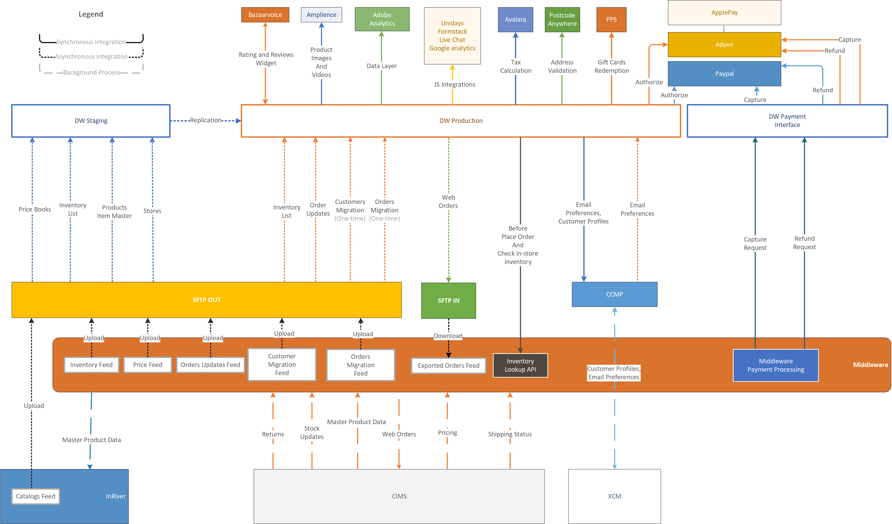

## References

|  |  |
| --- | --- |
| Document Name | Document Location |
| Business/User Requirement Specification | <https://fatface.atlassian.net/secure/RapidBoard.jspa?rapidView=21&projectKey=IHUB&view=planning.nodetail&epics=visible> |
| Requirement Traceability Matrix | Shruthi to update |
| SOA Service Registry | NA |
| Source Code | <https://github.com/FatFace/IntegrationHub> |
| Configuration files (Production  & Lower environments) | All config files are part of the code repository. The encryption key used for the production is as follows:   * Sanbox: jabdlgue34btiu2s * Production: jICm13MRF5IspiPe   The encryption algorithm used is AES. |
| DB Scripts | <https://github.com/FatFace/IntegrationHub/tree/master/database> |
| Service Design Documents (SDDs) or Low Level Design Documents | <https://fatface.atlassian.net/wiki/spaces/IHUB/pages/93288997/2.4+SDD> |
| Data Mapping Sheets | <https://fatface.atlassian.net/wiki/spaces/IHUB/pages/93227839/2.3+Interface+Mapping+sheets> |
| MUnit Test Suites | Offshore to update |
| Functional Test Suites | Offshore to update |
| SonarQube Code Review Report | Offshore to update |
| Regression Test Suites | Offshore to update |
| System Test Suites and Test Cases | Offshore to update |



# Pre-requisites

## Software

|  |  |
| --- | --- |
| Software Tools/Applications | Version |
| **CloudHub** | 3.8.4 Runtime |
| **GitHUB – FatFace** | NA |
| **Jenkins – FatFace** | TBC |
| **Confluence – FatFace** | On cloud |
| **MS-SQL on-premise database** | 2016 |
| **AWS RDS Database (MS-SQL BYOL)** | On cloud (2016) |
| **AWS SQS** | On cloud |
| **Maytech SFTP** | On cloud |
| **SonarQube – FatFace** | TBC |

## Firewall Configuration

The firewall configuration is managed by FatFace IT. Please contact FatFace service delivery manager for any specific details around the Firewall configuration. The current firewall configuration in the CloudHub is given below for reference.

**Production Firewall configuration**

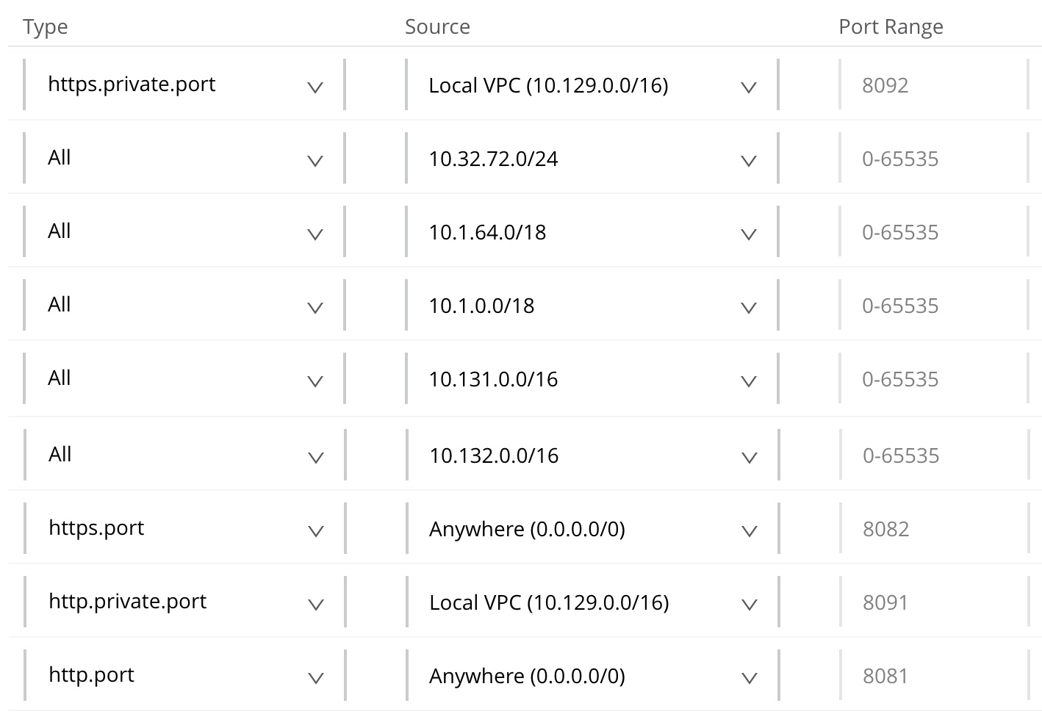

**Sandbox Firewall configuration**

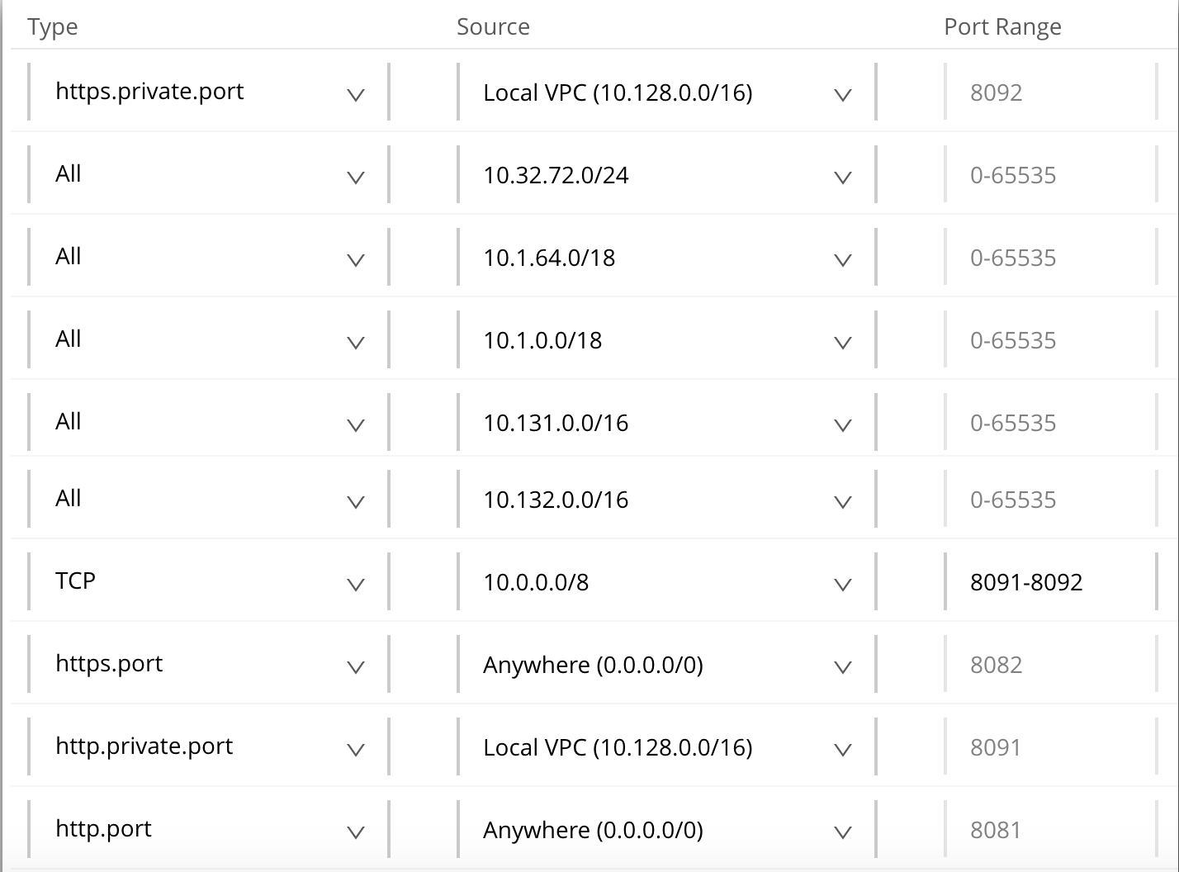

## Environment

There are four environments created for FatFace which are as shown below.

* Production
* UAT
* SIT
* Development

As most of the Fatface backend systems have only two environments (test and production), all testing is done from SIT environment itself and UAT environment is currently unused. This may be used in future once a UAT environment for core systems such as CIMS and JDA are created.

There are 4vCores available for Production whereas Development, SIT and UAT collectively share 4vCores.

### MuleSoft Server Configuration

All MuleSoft applications are running on CloudHub. Details around other servers can be found in the section 4.1.1.42 of the FatFace HLD. A quick link for the HLD us given below.

<https://fatface.atlassian.net/wiki/download/attachments/91790054/FatFace_DemandwareIntegr_FFLL1_HLD.docx?api=v2>

### Database Server Configuration

All on-premise database servers are managed by FatFace IT and specific details are not available with us. Details on the AWS RDS database is available in section 4.1.1.42 of the FatFace HLD.

### Dependent Application Configurations

NA

# Dependencies

## Dependent Applications

|  |  |
| --- | --- |
| Dependent Applications | Description |
| **MS SQL Server Demandware DB** | A reporting database hosted on premise to hold all order and payment related data. Please refer IHUB-166 and IHUB-166 and IHUB-168 for details on the reporting requirements. |
| **Maytech SFTP** | Used for all files based integrations in Mule. Please refed HLD for details on SFTP directory structure and their usage. |
| **Amazon SQS** | Used for order create functionality. Please refer SDDs for IHUB-6 for details. |
| **Amazon RDS** | Used for data migration (one time activity) and MuleSoft API audit (30 days of data is maintained in audit table). |

## Dependent Services

|  |  |
| --- | --- |
| Dependent Applications | Description |
| **CIMS SOAP web service** | Used for all transactions around CIMS. |
| **Demandware Payment API** | Used for payment capture, refund and cancellation for an order in Demandware payment gateway. |
| **CCMP Email API** | Used to send emails to customer for delivery, refund and cancellation scenarios. |
| **InRiver/PIM product API** | Used to send product feed to InRiver/PIM |

# Scheduled Jobs

All job schedules are captured in below spreadsheet.

<https://fatface.atlassian.net/wiki/download/attachments/104890369/FatFace-IHUB-Interface%20Schedule%20Catalog.xlsx?api=v2>

Please refer “Mule Job” sheet for details on Mule job frequencies.

# Data Clean-up

## Database Clean-up

Following clean-up task will need to be performed on monthly basis.

1. Delete any audit data older than 30 days from MuleSoft audit table (both Production and sandbox).

Above clean-up needs to be done manually on 15th of every month (15/11/2017 was the actual go live). [IHUB-1005](https://fatface.atlassian.net/browse/IHUB-1005) is logged to automate the clean-up of audit tables and is currently waiting for actions from FatFace side.

## File Repository Clean-up

Following clean-up task will need to be performed on monthly basis.

1. Delete any files from SFTP server (root location “FatFace/”) which is older than 30 days.

Above clean-up needs to be done manually on 15th of every month (15/11/2017 was the actual go live). [IHUB-1006](https://fatface.atlassian.net/browse/IHUB-1006) is logged to automate the clean-up of files on the SFTP server and is currently waiting for actions from FatFace side.

# Deployment Process

## Source Control & Release Process

Source code are maintained in FatFace GitHub repository at below link.

<https://github.com/FatFace/IntegrationHub>

This is a private repository so one will need a FatFace account to access the repository.

## Build Automation Process

Due to no CI server availability in the beginning from FatFace side, the Jenkins jobs are currently available in WHISHWORKS infrastructure and the URL to access the jobs is as follows.

<http://muledev.int.whishworks.com>

The WHISHWORKS Jenkins uses SVN to do a build so code was being pushed from GitHub to SVN for SoanrQube analysis and running the MUnit tests.

CI server is being setup on FatFace now so this section will be updated soon with FatFace relevant details.

Until CI server is setup in FatFace, the build may need to be created using maven locally using below command.

* mvn clean package

|  |  |
| --- | --- |
| Document Name | Document Location |
|  |  |

# Testing

## Test Suites

To be updated by Testing team

# Maintenance

## Health Checks

### Functional Checks

Below listed functional checks can be performed daily

* Monitor CloudHub Alerts for Production deployed applications related Errors
* Monitor CloudHub schedule jobs for its status
* Monitor files are generated and copied to respective FTP or SFTP folders
* Monitor audit logs for any errors and liaise with business for reprocessing the failed records if required.

### Sanity Checks

Below listed sanity checks to be done daily

* Monitor CloudHub APIs are running
* Sanity check is performed when application is deployed in any environment like dev and sit. If changes deployed in production, will ask business team to process a single record to ensure that is the change is working fine.

### Performance Checks

Below listed performance checks to be done regularly.

* Monitor the CPU & Memory of CloudHub for its performance

### Infrastructure Checks

Below listed infrastructure checks to be performed manually

* Check if VPN connection or on-premise systems are working from both CloudHub and local machines.

## Monitoring Alerts

Following alerts are in scope for the current phase of the project.

|  |  |  |  |  |  |  |  |  |
| --- | --- | --- | --- | --- | --- | --- | --- | --- |
| # | Mule application name | Memory > 75 | CPU > 75 | Worker not responding | SFTP connection failure | HTTP connection failure | Database connection failure | AWS SQS connection failure |
| 1 | x-dw-web-api | X | X | X |  |  | X |  |
| 2 | x-payment-request-api | X | X | X |  |  | X |  |
| 3 | x-order-status-api | X | X | X |  |  | X |  |
| 4 | x-customer-api | X | X | X |  |  | X |  |
| 5 | p-cims-data-int | X | X | X |  | X | X | X |
| 6 | p-jda-data-int | X | X | X |  | X | X |  |
| 7 | p-dw-data-int | X | X | X |  | X | X |  |
| 8 | s-pim-data-int | X | X | X |  | X | X |  |
| 9 | s-jda-data-int | X | X | X | X | X | X |  |
| 10 | s-ccmp-data-int | X | X | X |  | X | X |  |
| 11 | s-dw-data-int | X | X | X | X | X | X |  |
| 12 | s-cims-data-int | X | X | X |  | X | X | X |
| 13 | s-intraface-data-int | X | X | X | X | X | X |  |

Following alerts have been created in CloudHub to address above alerting requirements.

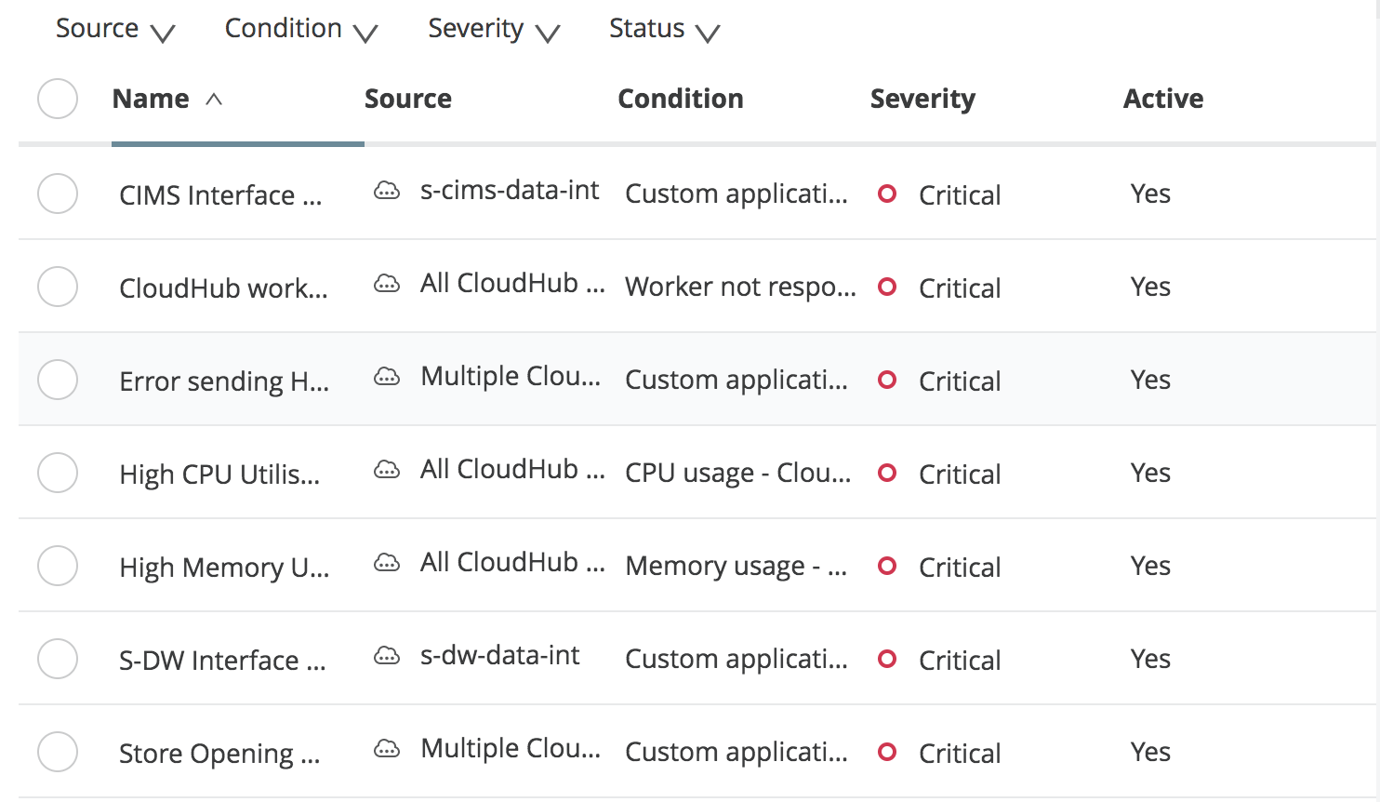

Not all alerts have been tested. New alerts may need to be configured to meet above alerting requirements.

## Server Logs

Currently there are no automated log download in place. This is being investigated and we shall aim to automate this process as early as possible. Until an automation is in place, logs should be periodically downloaded and checked for errors. Please maintain all logs on the SFTP server at “/FatFace/sftp/MuleSoftIntegration/<environment>/logs/”.

## Troubleshooting

* Most of the issues are being notified via an email and the email contains the message_id and request_id of the transactions that has caused an alert. Troubleshooting of an issue should start with downloading the logs and tracing the error using the message_id or request_id. If sufficient details are not available in the logs, one can retrieve the payload from audit table and try and replicate the issue in lower environment with debug logs enabled. In case, message_id or request_id is not available in logs, the only way to trouble sheet the issue will be by downloading the logs and investigating the transaction that has failed.
* In case of connection issue between MuleSoft CloudHub environment and on-premise connection issue, support can deploy “net-tools-fatface-api” application (already available in applications) and open the web console of the application using “[**net-tools-fatface-api.eu.cloudhub.io**](http://net-tools-fatface-api.eu.cloudhub.io/)”. Further support can try to capture some stats such as ping, socket connection, traceroot etc. The same application is available in SIT environment with the name “sit-fatface-net-tools-api”. The credentials to login is part of the code. Please download the deployment ZIP and extract the login details from “mule-app.properties” file.
* Following are some of the key DEBUG logs that could be enabled in sandbox environment for troubleshooting any issues.
  + org.mule.transport.sftp – enable debug for SFTP transport
  + org.mule.transport.jdbc – enable debug for JDBC transport
  + com.ning.http – enable debug for HTTP calls
  + org.mule.module.http.internal.HttpMessageLogger – enable debug for HTTP calls
  + org.apache.cxf – enable debug for HTTP calls
  + org.mule – enable debug for all mule components

**Note** that DEBUG should not be enabled in Production as it may impact the performance of the applications. Any debugging should be carried out test environment and debug should be disabled once the investigation is done.

# Reporting

|  |  |  |  |
| --- | --- | --- | --- |
| Report Name | Report Format | Report Contents | ESB Service Support Contact |
| **Daily Health Check Report** | An excel sheet with checklist and verification details of all Mule ESB servers, SQL Server DB and Cloud Hub servers in both pre-production and production environments | Server Health Check List, ESB Application Statuses, Alerts, Batch Job Statuses, DB Alerts, Capacity Checks, Memory utilization and License Information etc. | TBC |
| **Weekly Status Report** | A weekly summary of support activities and incidents of the previous week | Key achievements of the past week, incident and service request summary, risks, issues and ticket ageing analysis etc. | TBC |
| **Monthly Report** | A detailed report with all incidents, problems and support activities carried out in the previous month | Incidents, Problems, changes, minutes of monthly review meeting etc. | TBC |

# Disaster Recovery Procedure

Yet to be identified.

# Escalation Procedure

|  |  |  |  |  |
| --- | --- | --- | --- | --- |
| Priority | Escalation Time  beyond SLA | Escalation Point 1 | Escalation Point 2 | Escalation Point 3 |
| **P1** | + 30 Min | TBC | TBC | TBC |
| **P2** | + 1 Hour | TBC | TBC | TBC |
| **P3** | + 1 Day | TBC | TBC | TBC |
| **P4** | + 3 Days | TBC | TBC | TBC |

Please refer the supplier documents in the below link for details on escalation procedure for individual suppliers.

<https://fatface.atlassian.net/wiki/spaces/IHUB/pages/115605505/Supplier+Documentation>

For FatFace escalation, you should contact the FatFace service delivery manager.

# Risks and Assumptions

## Known Issues/Risks

|  |  |
| --- | --- |
| Issue Description | Proposed/Intended Solution (If Any) |
| **Large file streaming/VPN connection issue/Planned downtime on CIMS/CIMS service is unavailable** | This will be planned with phase 2 release. Until this is fixed, support should work with business not queue orders in Demandware. In case of any downtime on CIMS side or any VPN issues, support should liaise with business to get the Demandware “Mule Order Export” directory location changed temporarily so that Demandware can continue to export the files on the SFTP server. Once the issues with VPN or CIMS is resolved, the files queued on the SFTP server should be processed manually by moving them to the correct export location. Max 5 MB files should be processed at once.  The details on how to change the Demandware “Mule Order Export” target location is captured in a separate document available in FatFace confluence at below link.  [https://fatface.atlassian.net/wiki/download/attachments/115376129/Changing Order Export Job SFTP location in Demandware.docx?api=v2](https://fatface.atlassian.net/wiki/download/attachments/115376129/Changing%20Order%20Export%20Job%20SFTP%20location%20in%20Demandware.docx?api=v2) |
| **Audit database clean-up** | There is no automated audit DB clean job available in sandbox or production. Clean-up should be done manually until IHUB-1005 is fixed. |
| **SFTP files cleanup** | There is no automated SFTP files clean job available in sandbox or production. Clean-up should be done manually until IHUB-1006 is fixed. |
| **UTF-8 characters not support by CIMS** | There are few international orders which fail due to special characters in the address field. Not all special characters are currently supported by CIMS orderCreate service. Such issues will be reported via the alerts and support team should liaise with business to provide correct address and manually process those orders to CIMS.  The manual processing can be done using the internal worker URL for OrderCreate API or by calling CIMS web service directly using Soap-UI. |
| **Payment capture/refund/cancel failure** | Demandware payment API sometimes fail to process the payment and returns an error to MuleSoft. A retry is being implemented in MuleSoft API but a daily report will be required on the payment failure and CIMS may need to resend the payment request if payment processing fails from Demandware.  This report currently does not exists so manual query may be required. |
| **Object store key not found exception** | This issue occurs in “s-ccmp-data-int” application occasionally. This is a known bug on MuleSoft side and an enhancement request is logged for a fix. Please refer case number “00180765” on MuleSoft support for progress. |
| **Error '' occurred when trying to CDW** | This issue occurs in logs occasionally. This has no business impact. A MuleSoft ticket ([00180648](https://support.mulesoft.com/s/case/5003400000zPKRGAA4)) is logged for this issue and this is being investigated with MuleSoft and Maytech. |

## Assumptions

TBC

# Appendix

**Useful SQL queries around audit table.**

1. To get a report on all calls to price-book feed on a particular date.

|  |
| --- |
| ;WITH XMLNAMESPACES ('http://xdi/FFService.wsdl' AS ns2,  'http://www.prologic.com/schema/cims/ff_service/priceFeedResponse' AS priceFeed)  SELECT  ID, message_id,  convert(xml,log_message).value('(/ns2:PriceFeedResponse/priceFeed:priceFeedOUTPUT/@XDI_ID)[1]', 'nvarchar(max)') as XDI_ID,  convert(xml,log_message).value('(/ns2:PriceFeedResponse/priceFeed:priceFeedOUTPUT/@MAX_ID)[1]', 'nvarchar(max)') as MAX_ID,  convert(xml,log_message).value('(/ns2:PriceFeedResponse/priceFeed:priceFeedOUTPUT/@Type)[1]', 'nvarchar(max)') as FeedType,  convert(xml,log_message).value('(/ns2:PriceFeedResponse/priceFeed:priceFeedOUTPUT/PRICE_LISTS/PRICE_LIST/@Name)[1]', 'nvarchar(max)') as PriceListName,  record_create_time as AuditCreatedTimestamp,  convert(xml,log_message).value('(/ns2:PriceFeedResponse/priceFeed:priceFeedOUTPUT/@CalledAt)[1]', 'nvarchar(max)') as CIMSRequestTimestamp,  convert(xml,log_message).value('(/ns2:PriceFeedResponse/priceFeed:priceFeedOUTPUT/@Timestamp)[1]', 'nvarchar(max)') as CIMSResponseTimestamp  FROM  t_audit  where  log_type='CALL EXIT'  and instance_thread='get:/pricebook:s-cims-api-config'  and record_create_time>'YYYY-MM-DD'  order by Id desc; |

1. To get a report on all calls to price-book feed on a particular date.

|  |
| --- |
| ;WITH XMLNAMESPACES ('http://xdi/FFService.wsdl' AS ns2,  'http://www.prologic.com/schema/cims/ff_service/stockFeedResponse' AS stockFeed)  SELECT  ID, message_id,  convert(xml,log_message).value('(/ns2:StockFeedResponse/stockFeed:stockFeedOUTPUT/@XDI_ID)[1]', 'nvarchar(max)') as XDI_ID,  convert(xml,log_message).value('(/ns2:StockFeedResponse/stockFeed:stockFeedOUTPUT/@MAX_ID)[1]', 'nvarchar(max)') as MAX_ID,  convert(xml,log_message).value('(/ns2:StockFeedResponse/stockFeed:stockFeedOUTPUT/@Type)[1]', 'nvarchar(max)') as FeedType,  record_create_time as AuditCreatedTimestamp,  convert(xml,log_message).value('(/ns2:StockFeedResponse/stockFeed:stockFeedOUTPUT/@CalledAt)[1]', 'nvarchar(max)') as CIMSRequestTimestamp,  convert(xml,log_message).value('(/ns2:StockFeedResponse/stockFeed:stockFeedOUTPUT/@Timestamp)[1]', 'nvarchar(max)') as CIMSResponseTimestamp  FROM  t_audit  where  log_type='CALL EXIT'  and instance_thread = 'get:/inventory-list:s-cims-api-config'  and record_create_time>'YYYY-MM-DD'  order by Id desc; |

1. To get a report on all calls to product feed on a particular date.

|  |
| --- |
| ;WITH XMLNAMESPACES ('http://xdi/FFService.wsdl' AS ns2,  'http://www.prologic.com/schema/cims/ff_service/productFeedResponse' AS productFeed)  SELECT  ID, message_id,  convert(xml,log_message).value('(/ns2:ProductFeedResponse/productFeed:productFeedOUTPUT/@XDI_ID)[1]', 'nvarchar(max)') as XDI_ID,  convert(xml,log_message).value('(/ns2:ProductFeedResponse/productFeed:productFeedOUTPUT/@MAX_ID)[1]', 'nvarchar(max)') as MAX_ID,  convert(xml,log_message).value('(/ns2:ProductFeedResponse/productFeed:productFeedOUTPUT/@Type)[1]', 'nvarchar(max)') as FeedType,  record_create_time as AuditCreatedTimestamp,  convert(xml,log_message).value('(/ns2:ProductFeedResponse/productFeed:productFeedOUTPUT/@CalledAt)[1]', 'nvarchar(max)') as CIMSRequestTimestamp,  convert(xml,log_message).value('(/ns2:ProductFeedResponse/productFeed:productFeedOUTPUT/@Timestamp)[1]', 'nvarchar(max)') as CIMSResponseTimestamp  FROM  t_audit  where  log_type='CALL EXIT'  and instance_thread='get:/products:s-cims-api-config'  and record_create_time>'YYYY-MM-DD'  order by Id; |

1. To retrieve an audit of all transactions made against an order

|  |
| --- |
| select * from t_audit where  record_create_time > '2017-11-04 00:07:00.00'  and message_id in (select message_id from t_audit where record_create_time > '2017-11-04 00:07:00.00')  and log_message like '%UKF1000096098%'  order by record_create_time asc |

1. To retrieve CIMS request and response for a particular order

|  |
| --- |
| select * from t_audit where  record_create_time > '2017-12-04 00:07:00.00'  and instance_thread='s-order-api-main-sqs-create-order'  and request_id in (  select request_id from t_audit where  record_create_time > '2017-12-04 00:07:00.00'  and instance_thread='s-order-api-main-sqs-create-order'  )  and log_type in ('ERROR', 'CALL ENTRY', 'SUCCESS')  and instance_thread='s-order-api-main-sqs-create-order'  and log_message like '%UKF1000210190%'  order by record_create_time asc |

1. To get the log message as XML where full request or response cannot be copied directly from management studio

|  |
| --- |
| select convert(xml,log_message) as XMLData from t_audit where request_id='9e07c714-36ed-4e30-93bf-b6abb2a16e27'  OR  select convert(xml,log_message) as XMLData from t_audit where message_id='9e07c714-36ed-4e30-93bf-b6abb2a16e27' |

1. To check for Demandware Payment API request and response for a particular order.

|  |
| --- |
| select * from t_audit where  record_create_time > '2017-12-04 00:07:00.00'  and instance_thread='post:/payment-request:application/json:s-dw-api-config'  and message_id in (  select message_id from t_audit where  record_create_time > '2017-12-04 00:07:00.00'  and instance_thread='post:/payment-request:application/json:s-dw-api-config'  and log_message like '%UKF1000205850%'  )  and log_type in ('CALL ENTRY', 'CALL EXIT')  and instance_thread='post:/payment-request:application/json:s-dw-api-config'  order by record_create_time asc |

1. To check for CIMS Payment API request and response payload.

|  |
| --- |
| select * from t_audit where  record_create_time > '2017-12-04 00:07:00.00'  and instance_thread='post:/payment-request:application/xml:x-payment-request-api-main-config'  and message_id in (  select message_id from t_audit where  record_create_time > '2017-12-04 00:07:00.00'  and instance_thread='post:/payment-request:application/xml:x-payment-request-api-main-config'  and log_message like '%UKF1000205850%'  )  and log_type in ('ENTRY', 'EXIT')  and instance_thread='post:/payment-request:application/xml:x-payment-request-api-main-config'  order by record_create_time asc |

**Useful queries around reporting database**

1. To check history of payment API calls for an order

|  |
| --- |
| select  PaymentRequest.TransactionId,  PaymentRequest.OrderNumber,  PaymentRequest.Operation,  PaymentRequest.Amount,  PaymentResponse.Status,  PaymentResponse.ErrorCode,  PaymentResponse.ErrorDescription,  PaymentRequest.CreatedOn,  PaymentResponseTransactions.Processor,  PaymentResponseTransactions.Amount  from  PaymentRequest left join  PaymentResponse on PaymentRequest.TransactionId=PaymentResponse.TransactionId  left join PaymentResponseTransactions on PaymentRequest.TransactionId=PaymentResponseTransactions.TransactionId  where  PaymentRequest.OrderNumber in ('UKF1000205850')  order by  PaymentResponse.CreatedOn asc |

To check order details in the Demandware order reporting tables

|  |
| --- |
| select * from FF_Order where order_no='UKFT10125690'  select * from FF_Customer where order_id=(select ID from FF_Order where order_no='UKFT10125690')  select * from FF_ProductLineItem where order_id=(select ID from FF_Order where order_no='UKFT10125690')  select * from FF_OrderLineStatus where order_no='UKFT10125690'  select * from FF_Payment where order_id=(select ID from FF_Order where order_no='UKFT10125690')  select * from FF_Address where customer_id=(select ID from FF_Customer where order_id=(select ID from FF_Order where order_no='UKFT10125690'))  select * from FF_OrderTotals where order_id=(select ID from FF_Order where order_no='UKFT10125690')  select * from FF_Totals where ID in (377650,377646,377652,377653,377654)  select * from FF_Shipment where order_id=(select ID from FF_Order where order_no='UKFT10125690')  select * from FF_ShipmentTotals where order_id=(select ID from FF_Order where order_no='UKFT10125690')  select * from FF_ShippingLineItem where Order_id=(select ID from FF_Order where order_no='UKFT10125690')  select * from FF_Note where order_id=(select ID from FF_Order where order_no='UKFT10125690')  select * from FF_CustomAttribute where order_id=(select ID from FF_Order where order_no='UKFT10125690')  select * from [Status] where [order-no]='UKFT10125690' |

***End of Document***